Letter for parents about COVID-19 symptoms
Public Health England have produced a letter for schools to distribute to parents which explains when a person requires a coronavirus test and what the symptoms of coronavirus are. The Department would be grateful if you could share and circulate this letter amongst parents at your school.
The intention of the letter is to help prevent children being taken out of school unnecessarily and answer some of the questions parents may have around testing.
.

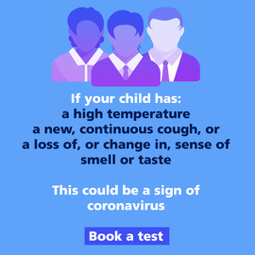 | 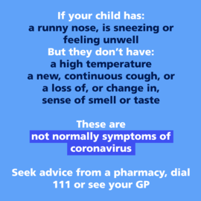

You can also download these images to use on your website or social media channels. Click/tap on the image above and right click/long tap to save the image.

Keep up to date
Subscriber services
Manage preferences or unsubscribe | Contact us | Help
Update your subscriptions, modify your password or email address, or stop subscriptions at any time on your Subscriber Preferences Page. You will need to use your email address to log in. If you have questions or problems with the subscription service, please visit subscriberhelp.govdelivery.com.

This service is provided to you at no charge by Department for Education.

