**Week One**

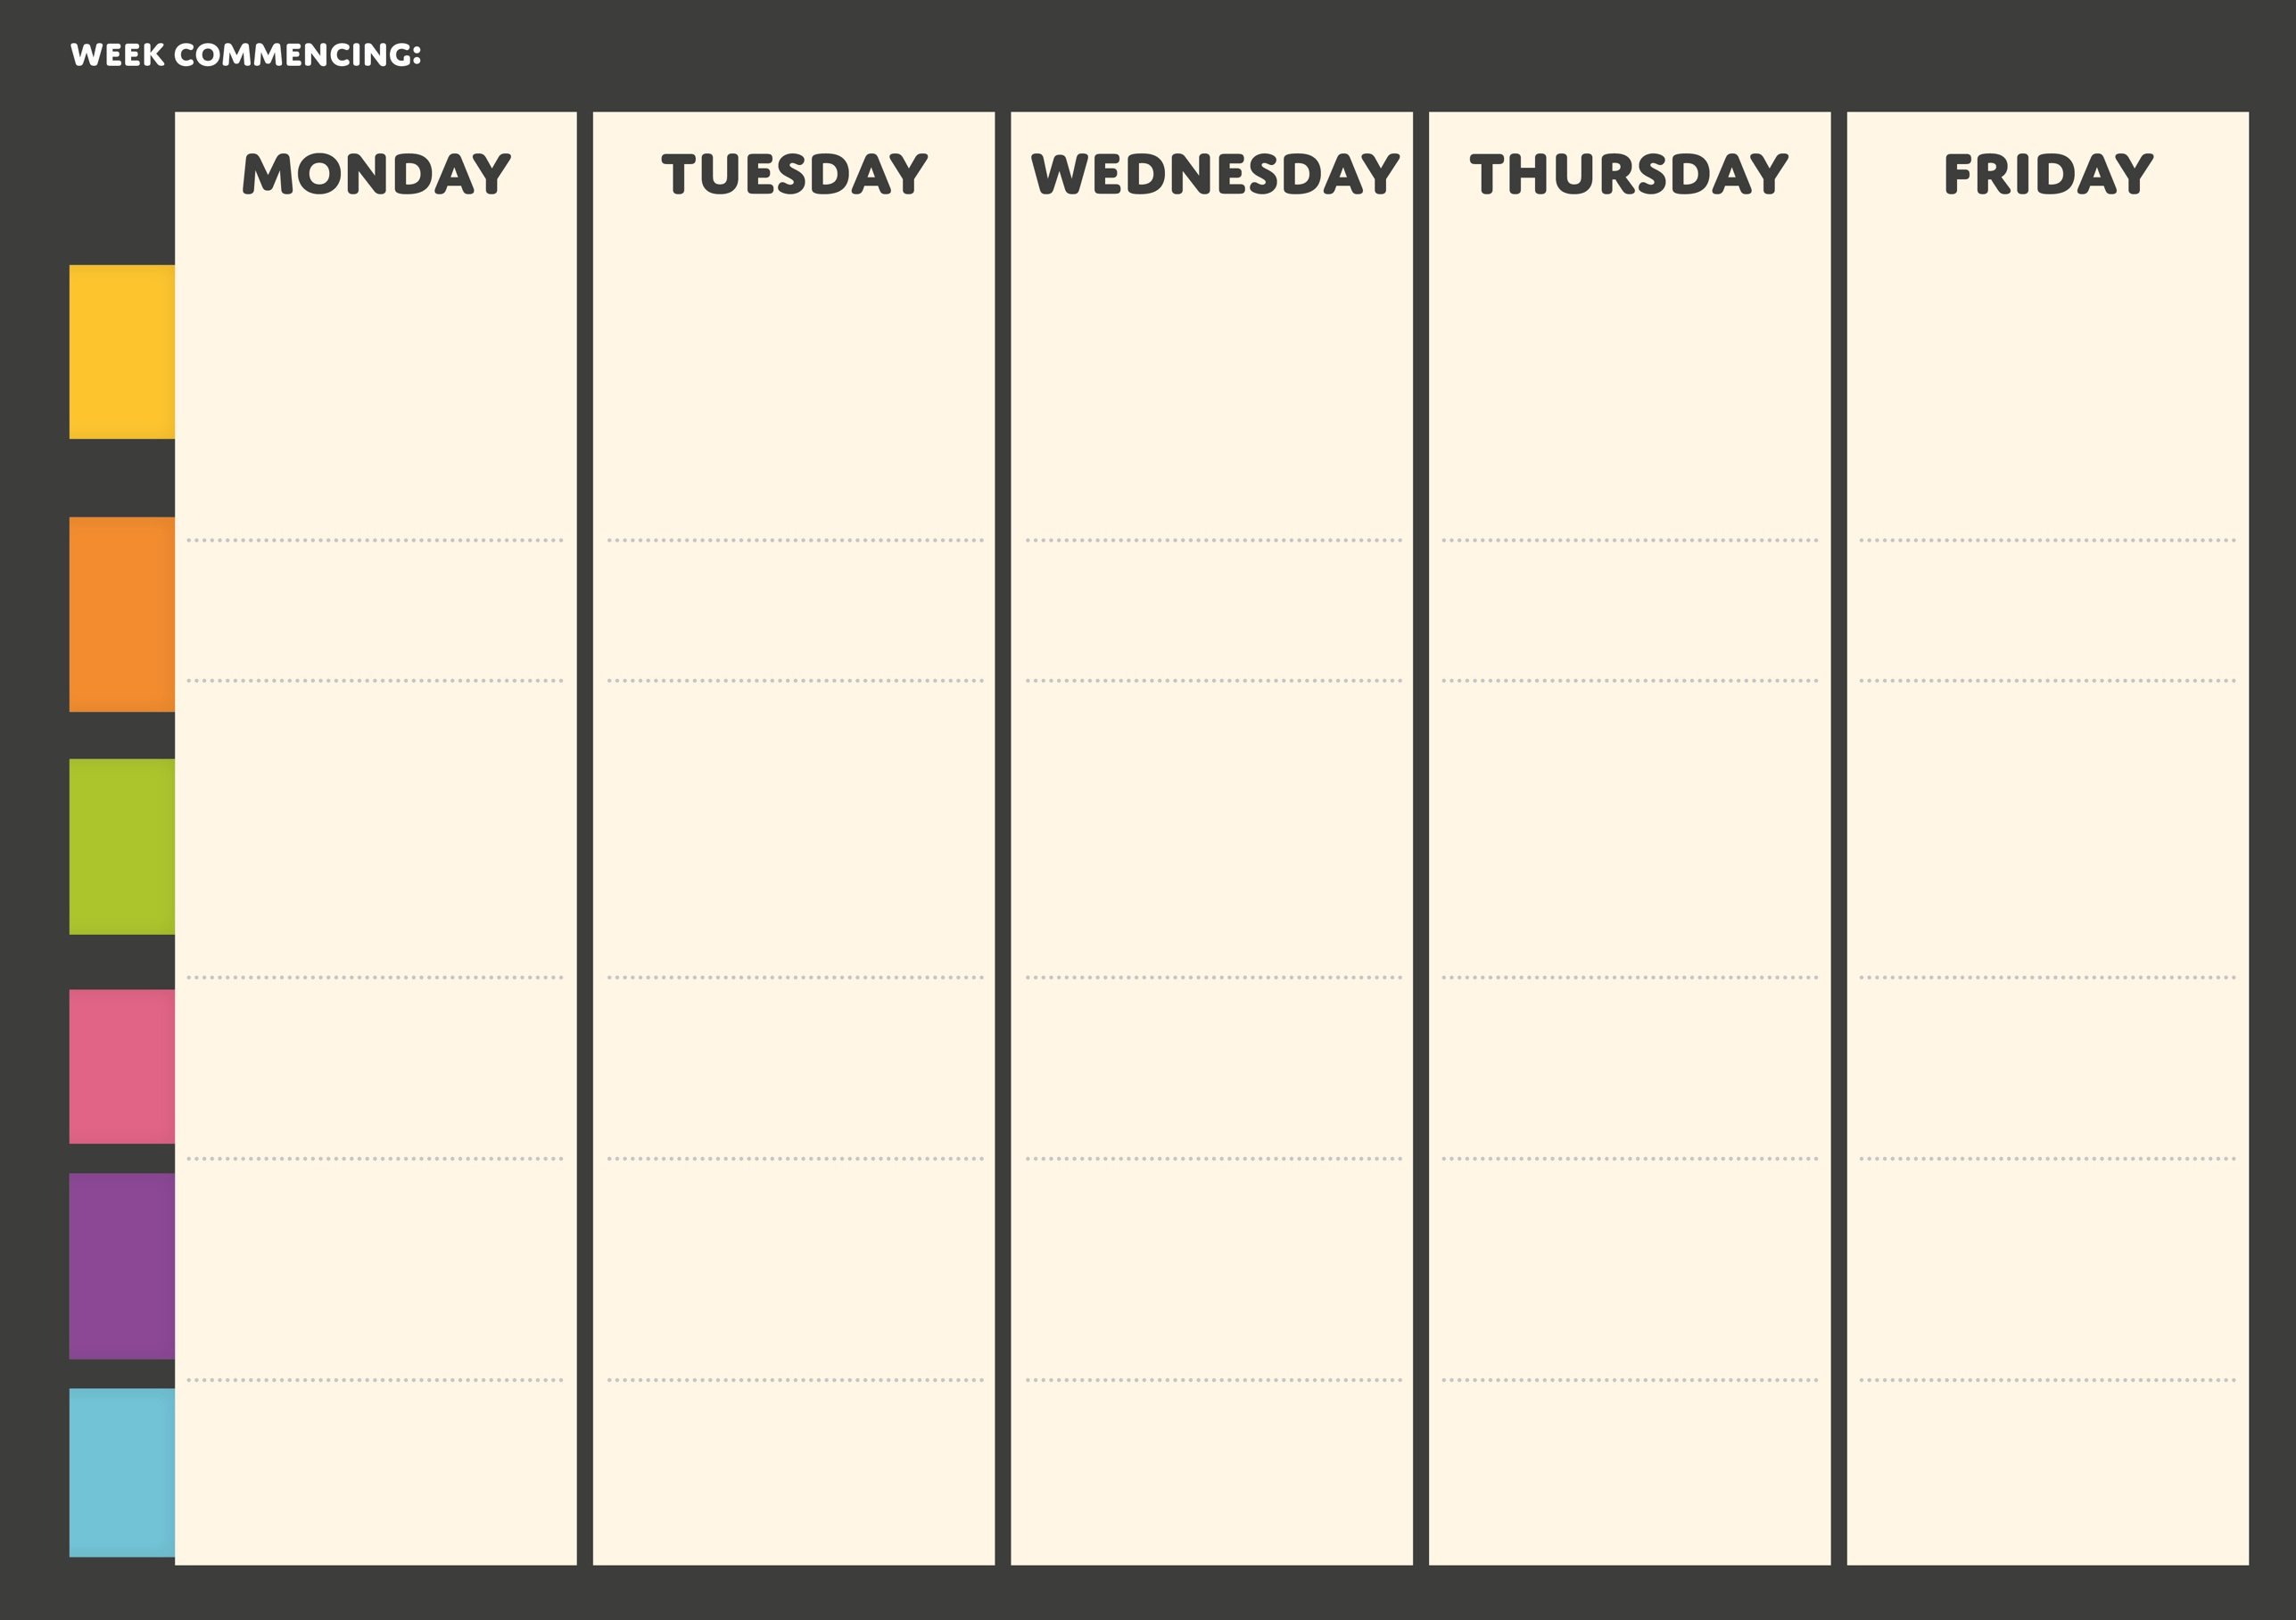

**Noodles with selection of sauces and vegetables**

**HOT**

**GRAB & GO**

**PASTA**

**MAIN**

**FEATURED**

**DESSERT**

**VEGGIE**

**MAIN**

**Carrot cake (v)**

**School cake**

**(v)**

**Roast tomato and basil (v)**

**Spaghetti**

**Carbonara**

**Southern fried Quorn burger**

**with mayo**

**Roast vegetable burrito with Quorn**

**Falafel topped flatbread with roast veg and garlic dressing**

**Pizza with sweet chilli, veg and oregano**

**Beef burrito**

**with salad and mixed beans**

**Chip Shop Friday Fish, chips, peas and curry sauce**

**Tuscan chicken pasta**

**Creamy courgette pasta (v)**

**Chicken and chorizo penne**

**Stuffed jackets**

**(v)**

**Ham and mushroom Stromboli**

**BBQ meatball sub roll**

**Panni pizza with pepperoni**

**Freshly baked sausage roll**

**Marble cake and custard (v)**

**Chocolate brownie (v)**

**Courgette and lemon cake (v)**

**Chicken shawarma**

**with salad and rice**

**Noodles with choice of meat and selection of sauces and vegetables**

**Pizza with mozzarella and red peppers**