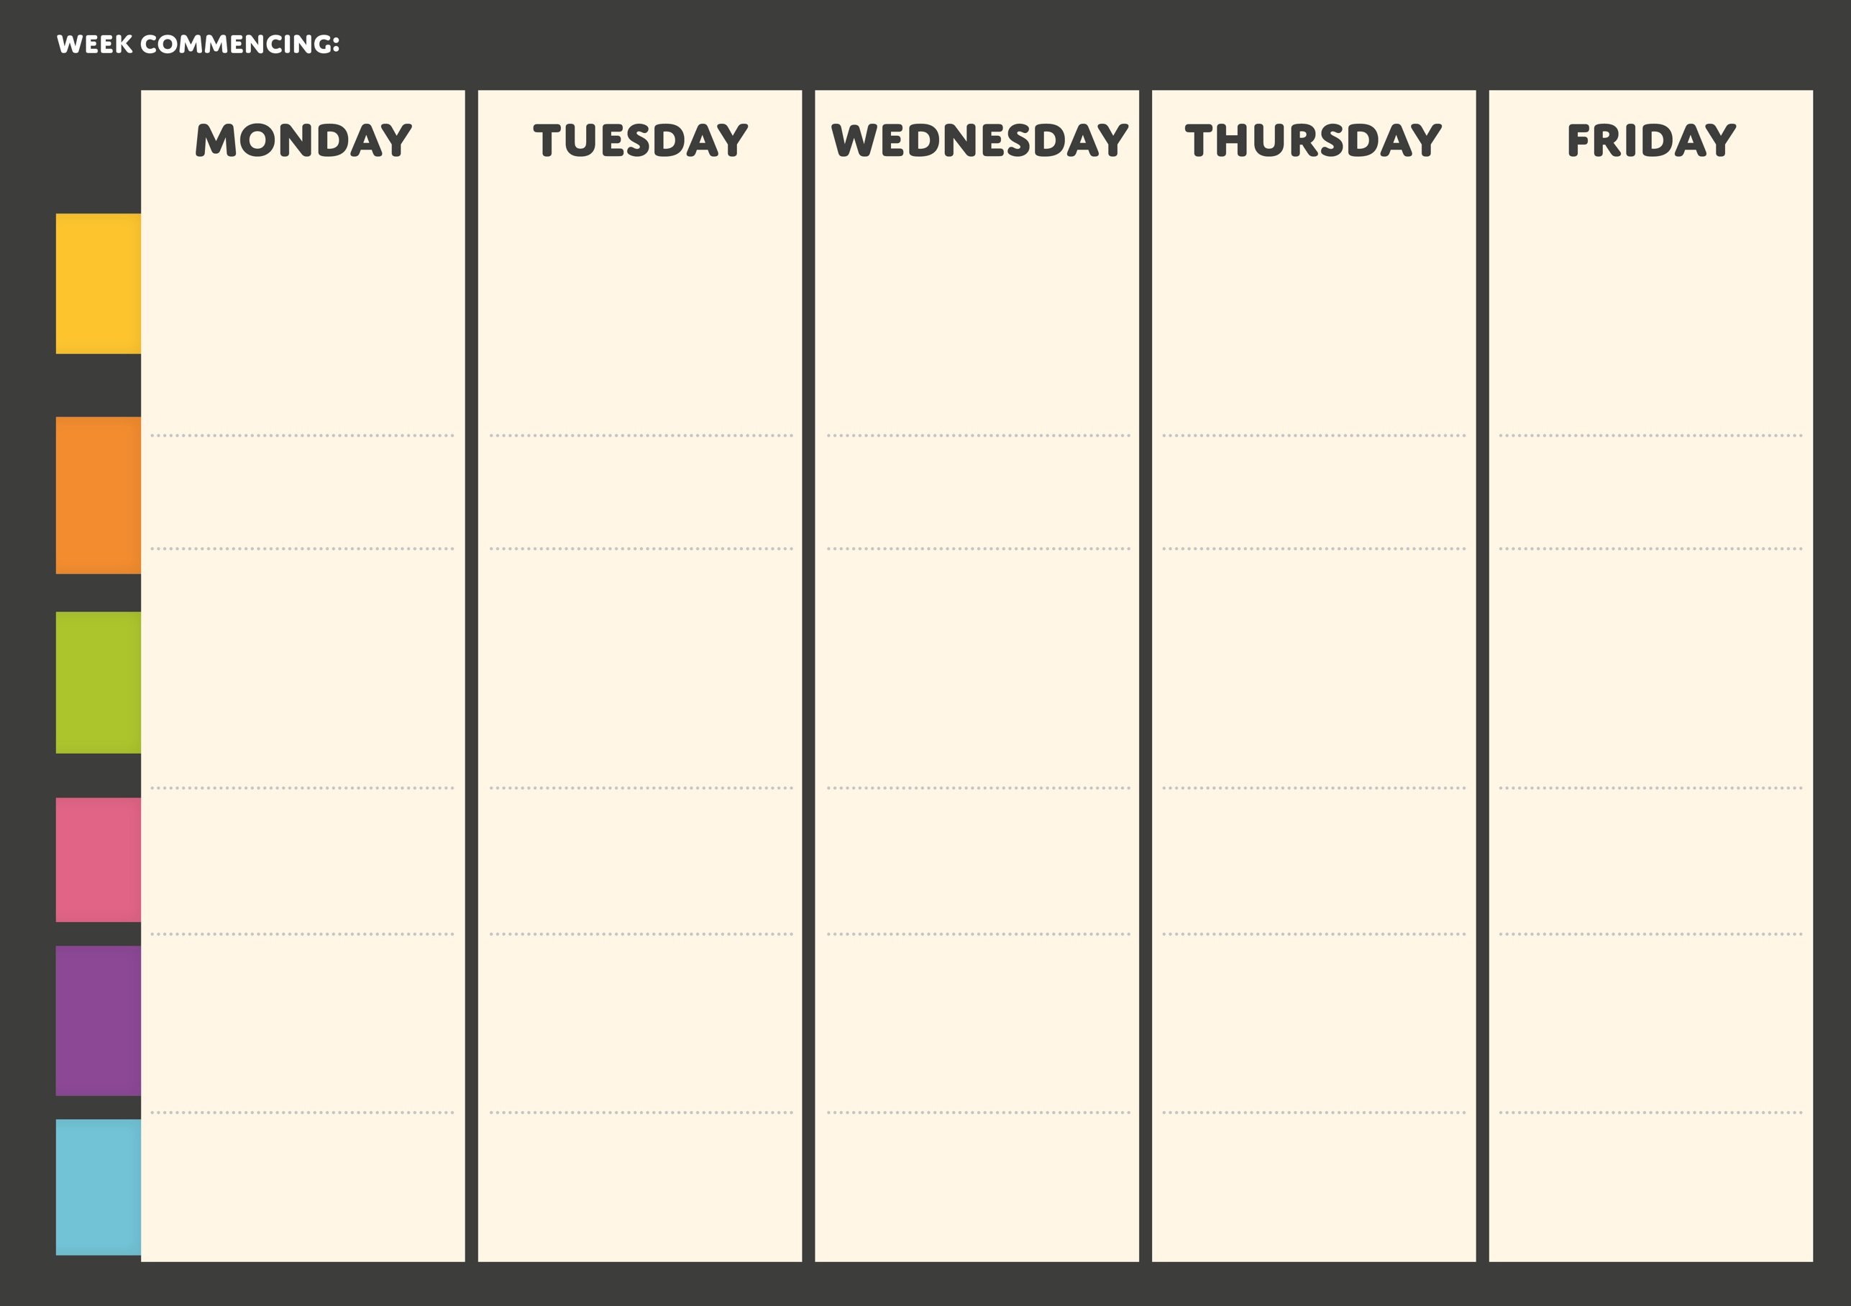

**Week Two**



**PASTA**

**HOT**

**GRAB & GO**

**DESSERT**

**VEGGIE**

**MAIN**

**Vanilla sponge with butter cream (v)**

**Lemon drizzle**

**cake (v)**

**Homemade shortbread (v)**

**Chocolate brownie (v)**

**Baked apple sponge with custard (v)**

**Spicy Sausage and Tomato**

**Mac & Cheese**

**with hidden veg (v)**

**Tomato and basil stromboli**

**(v)**

**Nachos with sauce and cheese**

**(v)**

**Pizza panni with oregano (v)**

**Freshly baked Sausage roll**

**Stuffed jackets**

**(v)**

**Spaghetti**

**Carbonara**

**Pesto pasta**

**penne (v)**

**Meatball pasta bake**

**Quorn pitta with vegetables, salad and choice of sauces**

**Vegetable**

**hot dogs with chips and onions**

**Cheese & Onion quiche with roast potatoes and veg**

**BBQ vegetable sausage wraps with salad and summer slaw**

**Rice with vegetables, katsu, teriyaki or sweet & sour sauce**

**FEATURED**

**MAIN**

**Rice with Quorn, katsu, teriyaki or sweet & sour sauce**

**Beef burger with bun and salad with selection of sauces**

**Roast Chicken with roast potatoes and gravy**

**Friday Fish & Chips with peas and tartar sauce**

**Gyros chicken pitta with salad, dip and mini potatoes**