Teaching & Learning
and
Professional Development

Contents:

- Teaching & Learning

- Curriculum Statement of Intent - p3
- Mechanisms of Learning – p4-5
- The Elements – p6-10
- Standards and Routines – p11

- CPD
- Core CPD – teaching and classroom support staff – p12-15
- Early Career Development – p16-17
- New Staff Induction – p18
- Enhanced CPD – p19-20
- Core & Enhanced Whole-Team Development – p21
- Leadership Development – p22-23

- The Teaching and Learning Team – p24 - 25

- Quality Assurance Processes and Systems – 26-27

- Teaching & Learning

Curriculum Statement of Intent
We aim to transform the lives of our students through our:
- Delivery of a focussed and purposeful curriculum. This will be designed by specialists, and delivered by passionate practitioners, which will equip students with the knowledge, skills and experiences they need to successfully enter the world of work.
- Commitment to being a values-driven Academy, who put our core values of empathy, honesty, respect and responsibility at the heart of everything we do. We aim to give all of our students the tools they need to flourish as young adults and continue to contribute positively to society.
- Dedication to all students leaving us as strong communicators: able to speak clearly, listen effectively, write coherently and understand the value of reading.
- Relentless focus on ambitious aspirations for all, ensuring that all our students are given opportunities and experiences that open their eyes to potential new pathways, partnered with the knowledge and skills required to flourish in this environment.
We aim to transform the lives of our students by:
- Ensuring high quality teacher instruction is at the heart of teaching and learning
- Ensuring recall and interleaving of content and acquisition of new knowledge is a priority
- Ensuring strong routines continually contribute to a safe and purposeful environment
- Removing barriers for all to allow them to leave us as well-rounded citizens who are able to positively contribute to society, with sufficient skills for future employment and education
- Providing opportunities for cultural experiences, linked to our curriculum.

Mechanisms of Learning
The “phases” of learning within a lesson / series of lessons which all expert teachers will employ. They …
- provide a consistency of structure to lessons
- support us in our intent to implement a focused and purposeful curriculum
- develop our students’ motivation and resilience
- provide us with a shared language and pedagogy across our Academy
- provide us with a shared language across the MAT

1 PCD (Planner, Copy, Do)
- Provides a clear structure at the start of every lesson supporting the Element of Focus & Purpose
- Links to our core value of responsibility
- Supports our high expectations of presentation and literacy
- Contributes to our intent to create strong and effective communicators through Language of the Lesson
- Supports pupils’ recall through the Do It Now task
2 Learning Links
- Improves pupils’ oracy
- Supports pupils to understand their learning journey
- Supports teachers’ lesson sequencing
- Provides an opportunity for pupils to develop schema
- Contributes to our intent to create strong and effective communicators
- Supports the Elements of Subject Passion and Expertise, Talking and Questioning and Reflect and Respond
3 Introducing New Knowledge
- Provides an opportunity for pupils to develop schema as they link prior knowledge to new knowledge
- Supports the Element of Subject Passion and Expertise
- Provides an opportunity to develop pupils’ cultural capital
4 Worked Example
- Provides students with models of work
- Helps students to learn to solve problems faster
- A step-by-step demonstration of how to perform a task or how to solve a problem (Clark, Nguyen, Sweller, 2006)
- Contributes to our intent of building a focussed and purposeful curriculum
- Supports the Elements of Subject Passion & Expertise and Talking & Questioning

5 Guided Practice
- Guides student practice. Allows more time guiding students’ practice of new material to mastery
- Checks for student understanding. Checking understanding during guided practice can help students learn the material with fewer errors
- Provides scaffold for tasks that is gradually reduced to facilitate learning towards independent practice
- Contributes to our intent of building a focussed and purposeful curriculum.
- Supports the Element of Pitch & Challenge
6 Independent Practice
- Provides a clear structure for pupils to complete independent work supporting and developing their motivation and resilience
- Links to our core value of responsibility
- Supports the Element of Reflect & Respond by allowing pupils to consider and respond to teacher feedback whether this is live feedback or feedback following teacher marking
7 Lesson Exit
- Provides a clear structure at the end of every lesson supporting the Element of Focus & Purpose
- Links to our core values of responsibility and respect
- Supports the motivation and resilience of our learners by providing precise praise for going above and beyond
- Ensures that ends of lessons are calm and purposeful as well as positive
- Supports pupils’ recall through the exit questions

The Elements
The Elements are a set of teaching and learning principles which all expert teachers share. They fully align with our statement of intent to transform the lives of our students by:
- Ensuring high quality teacher instruction is at the heart of teaching and learning
- Ensuring recall and interleaving of content and acquisition of new knowledge is a priority
- Ensuring strong routines continually contribute to a safe and purposeful environment
These principles underpin each and every Mechanism of Learning as well as providing a shared language and pedagogy across our Academy and across the MAT.

Subject knowledge has a very important role to play because high-quality teaching rests on teachers understanding the subjects they are teaching, knowing the structure and sequencing of concepts, developing factual knowledge essential to each subject and guiding their students into the different ways of knowing that subjects provide: subjects create disciplined ways of knowing. It is also clear that when there is a lack of subject expertise, or it is unevenly spread across teaching groups, then the quality of teaching and students' exam results are at risk. (Smithers & Robinson, 2005)

The most effective teachers have a deep knowledge of the subjects they teach. Teachers must also understand the ways students think about the content, be able to evaluate the thinking behind students’ own methods, and identify students’ common misconceptions.
(The Sutton Trust, 2004)

Subject Passion and Expertise
- Encourages students to go beyond the focused and purposeful curriculum
- Enables us to challenge all students
- Ensures insightful and effective planning of learning
- Enables misconceptions to be addressed
- Inspires and motivates students
- Enables us to break knowledge and skills down effectively

Talking and Questioning
- Supports our dedication to students leaving as strong communicators
- Enables us to model effective talk and vocabulary to develop the students’ numeracy, oracy and literacy using projection, pace, pause and posture
- Supports us in planning routines and frameworks to support effective classroom talk and literacy using phonological and morphological approaches
- Enables us to plan purposeful, and probing questions to ensure that all students are able to make excellent progress

"Young children in poverty need opportunities to learn words....rich exchanges with adults, particularly conversations, serve as a key mechanism to accomplish this goal"

(Waski and Hindman, 2005)

"Young children in poverty need opportunities to learn words....rich exchanges with adults, particularly conversations, serve as a key mechanism to accomplish this goal"

(Waski and Hindman, 2005)

“Children learned more new words when the adults around them used more complex vocabulary and inferential talk”

(Dickinson & Tabors, 2000)

‘In the USA, teachers plan what they want their students to do. In Shanghai, teachers plan what they want their students to think about.’ (Gu, 2005)

Focus and Purpose
- Students are focused and actively take responsibility for their learning
- Pace is appropriate for the point in the learning
- Students understand their learning journey
- Sequences of lessons are planned to develop skills and build on prior learning
- Positive behaviour leadership fosters an effective and purposeful learning environment including precise praise for going above and beyond and acknowledgement of expected behaviours
- Students track the speaker

Pitch and Challenge
- Enables our relentless focus on all students having ambitious aspirations
- Allows students to be inspired through careers/curriculum to seek purpose in their learning and how their learning links to employability and the wider world
- Allows all students to achieve their potential regardless of their starting points
- Sets high expectations and develops resilience
- Enables us to meet the needs of, and challenge, all students including those with SEND/EAL/LAP learners
- Ensures students have access to alternative provisions which are highly tailored to the needs of all
- “Teachers should assign tasks that are within students’ ZPD – learners should be stretched beyond their own independent ability, but not their ability with assistance.
- Tasks should be scaffolded so that students can isolate and solve the educative challenge and eventually learn to complete the tasks independently, but not so highly structured that they never learn to go alone.
- Giving students the hardest tasks they can do with scaffolding will lead to the greatest learning gains”.
(Wass and Golding, 2004)

Reflect and Respond
- Supports our students in understanding the four core values and how these apply to academy life
- Enables students to understand and reflect on how they learn
- Enables students to address misconceptions
- Supports us in reflecting on the performance of our classes and adapting the curriculum to meet the needs of our students
- Enables us to reflect on our own practice and take active steps to develop our knowledge and/or skills

“The key to stable motivation to learn depends on a student’s capacity to deploy self-regulatory strategies which strengthen their engagement with tasks that they may not find intrinsically interesting.” (Clark, 2002)

- Hattie – ‘formative evaluation’ 4th highest influence on student achievement with an effect size of 0.9
- Wiliam (1999) – good formative assessment can raise achievement by as much as two grades – disproportionately beneficial for LAPs.
- The Sutton Trust – meta-cognitive and self-regulation approaches have ‘consistently high levels of impact’ with students making an average of eight months additional progress.
- Research shows that explicitly teaching study strategies in content courses improves learning.

Standards and Routines

A full set of descriptors for all routines and each Mechanism of Learning linked to the relevant Elements can be found in the Teaching and Learning Folder of SharePoint.

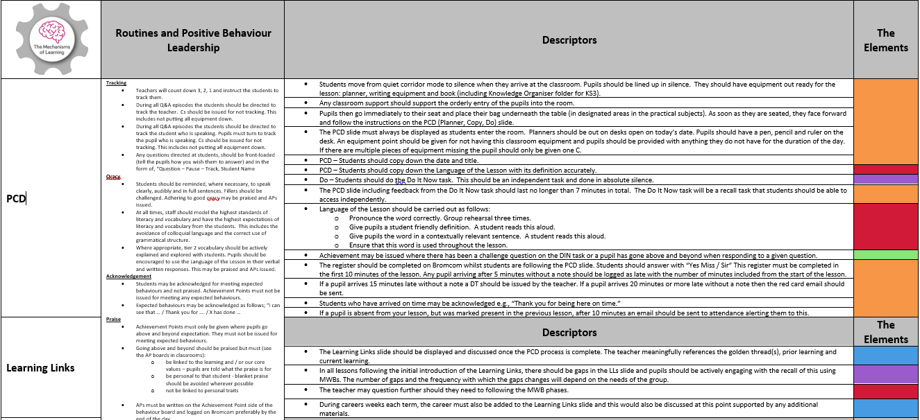

Overviews providing summaries of T&L routines can be also be found in the New Staff section of the Teaching and Learning folder of SharePoint.
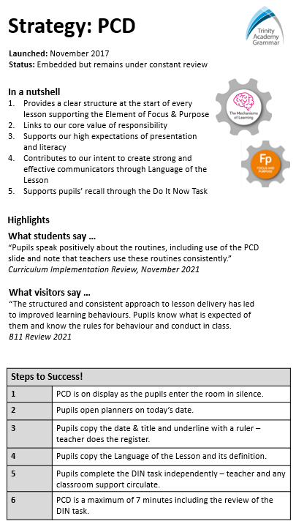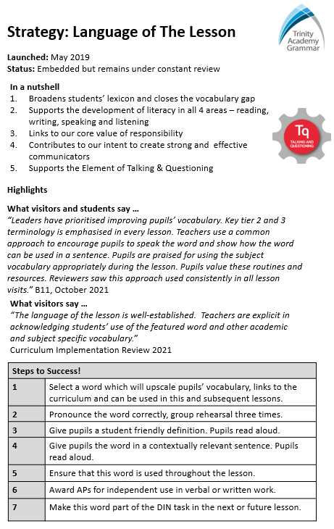

Overviews providing summaries of T&L routines can be found in R:\Curricular\Teaching & Learning\CPD\CPD 2022-23\Overviews.
2. CPD

Core CPD
Teacher CPD
Aimed at: Teaching Staff, Curriculum Tutors and Learning Mentors
At Trinity Academy Grammar, we recognise the importance of ongoing, high-quality professional development opportunities in order to support and develop the expertise of our staff at all stages of their career.
Aimed at all teachers, Curriculum Tutors and Learning Mentors this regular twilight CPD focuses on developing pedagogy and rendering staff practice consistent within all school priorities. All teaching staff CPD is based in educational research and underpinned by robust school quality assurance processes including regular teaching and learning data collections ensuring that all CPD is fully relevant to and focused on school improvement and staff development.

Examples
Whole group sessions | Mechanisms of Learning  The Elements  Literacy  EAL  Routines  Positive Behaviour Leadership  SEND  E-learning
Paired Data Input and Reflective Practice | Discuss student outcome with CLs  Review seating plans and annotations  Review strategies for individual students
Curriculum Review | Paired book looks  Visit reflections  Staff voice

Staff Voice
98% agree / strongly agree that the weekly teacher CPD sessions have had a direct impact on their practice.
“It is always made clear how CPD sessions are linked to wider academic research and how this fits with the academy’s vision. This highlights why new strategies are so important.”

Practice
Aimed at: All staff
Supporting the premise that practice makes permanent, practice is an embedded part of CPD and weekly pastoral CPD. Sessions may be supported by a script which clarify expectations of actions and language or a specified list of steps to success to meet the varying needs and / or levels of experience of our staff body.

Practice Examples | Language of the Lesson  Learning Links  PCD  Tracking  Think, Pair, Share  Entries  Exits  Careers  Attendance conversations  Acknowledgement vs praise  Issuing Cs  Reflection Image  The Pledge

Staff Voice
Practice sessions provide staff with the language necessary to best support our pupils. 96% agree / strongly agree
Practice sessions have had a direct impact on the consistency of routines at TAG. 100% agree / strongly agree
“Scripts are a useful discussion point to reflect on our own practice and use within the department.”
“I think the rationale behind why the change in language needs to occur which is always brilliantly shared with staff in CPD is more effective in shifting habits.”

Subject Specific CPD
Aimed at: Teaching Staff, Curriculum Tutors and Learning Mentors
This regularly scheduled twilight CPD for curriculum areas focused on developing and enhancing their curriculum and the subject expertise and pedagogy of their teams. CLs plan this CPD to meet the needs of their Faculty Improvement Plan as well as the needs of their staff. Plans are continually reviewed based on the quality assurance feedback gained including that from curriculum reviews – lesson visits, book looks, staff and student voice.

Examples | Areas identified in curriculum review – subject pedagogy / aspects of curriculum delivery / development / planning  Joint planning  Subject knowledge development  Engage with research  Topic seminars  Cross-curricular opportunities  Review misconceptions/teaching strategies  Ensure consistency of assessment and understanding mark schemes  Discuss and share assessments/mock exams  Standardisation and moderation  Exam review including examiner feedback

Staff Voice
100% of staff strongly agree / agree that curriculum CPD not only supports their development and practice but also has had a direct impact upon it.
“These have really improved my subject knowledge and developed consistency across the whole department.”
“This has allowed me to have clear tasks to develop curriculum and assessment.”

Classroom Support Staff CPD
Aimed at: Teaching Assistants (Curriculum Tutors and Learning Mentors by invite)
Recognising the invaluable role that our classroom support staff play, Teaching Assistants receive their own weekly CPD. This CPD aims to support TAs in understanding and supporting whole school routines and priorities and develop knowledge essential for their role. This, in turns, ensures that teaching staff receive the best quality classroom support.

Examples | Weekly Practice in-line with teaching staff CPD  Collaborative reviews of Pen Portraits  SEND – knowledge development  Classroom Support Staff Absolutes  Questioning  Literacy  Numeracy  Access training  Pastoral systems
Staff Voice
100% of staff strongly agree / agree that TA CPD not only supports their development and practice but also has had a direct impact upon it.
“CPD is always valuable and creates a forum for discussion and sharing of strategies with other staff. This is important to me because as a TA I am deployed in lots of departments so having the opportunity to reflect with other support staff is great for morale and learning from each other’s experiences too.”

Early Career Development

ITTs
Aimed at: Teach First Trainees and TIE trainees
At Trinity Academy Grammar, we work alongside our Teaching School (TIE), as well as with other external training providers including Teach First, to ensure that our trainees are equipped and motivated to become excellent practitioners. When trainees join us here, they will have a specialist subject mentor who will meet with them weekly and provide support and guidance. As well as having the opportunity to take part in all our Core CPD and New Staff Induction Programme they will be part of more bespoke CPD including 10 Minute Tips. This is designed to support the smooth transition into the classroom, enhance their pedagogy, and develop their skillset as they progress throughout their training year and beyond.

ECTs Year 1
Aimed at: All ECTs in Year 1
We understand that the first year of teaching brings about its challenges, and it can sometimes feel a little daunting. That is why we continue to ensure that our team are fully supported in all aspects of their career. When ECTs join us, they will be provided with a range of opportunities to support their professional development including a dedicated mentor who will be on hand to offer advice and guidance. Specifically, ECTs will be provided with the opportunity to experience:
- Our new staff induction package which also helps staff to familiarise themselves with our systems, policies and procedures
- Access to our Core CPD provision
- All ECTs have a mentor and a tutor to support their progress
- A weekly meeting with their mentor
- Access to StepLab to support their induction
- Our 10 Minute Tips programme
- ECTs receive regular formal and informal feedback to support their development.
- ECTs receive a bespoke programme of induction with partner schools.
- ECTs receive training through the Ambition platform and ongoing support from the Kirklees and Calderdale Hub for their 2 year ECF programme.

100% agree / strongly agree that they have found that the weekly mentor meetings support their development and practice and feel that they receive the necessary support to help them evidence the teachers’ standards.
“The routines and culture at TAG make evidencing the teaching standards easier.”
“School wide resources are impeccable, the culture of the school is exceptionally warm and all staff are more than willing to help.”

ECTs Year 2
Aimed at: All ECTs in their second year
As well continuing the ECT provision from year one, in order to bridge the gap between your first induction year and beyond, we have designed an additional bespoke CPD programme as part of our continuum of support. This programme aims to:
- create teachers who demonstrate expert subject knowledge, have a deep understanding of their curriculum and outstanding pedagogical practice
- prepare staff for future leadership opportunities
This programme gives Year 2 ECTs the following opportunities:
- Focus on developing outstanding pedagogical practice as well subject knowledge
- Identify a development focus which supports the development of the Y2 ECT whilst underpinning the development of the curriculum area in which they work
- Research the agreed focus with the support of their mentor
- Present the research and establish a development plan to put the identified focus into action
- Receive and engage with feedback provided on the agreed focus
The programme will culminate in Y2 ECTs be able to select a leadership task which could include:
- Planning and delivering CPD to the curriculum area based on development work carried out
- Working with the CL to carry out any curriculum developments that may have arisen from their development work
- Working with another colleague to develop their practice – mentoring / coaching
- All Y2 ECTs receive the opportunity to publish their work in the Trust’s educational journal, Spark.

Examples of Y2 ECT development foci | - Improving performance in MoR - retrieval and method impact  - Embed Grammar Pop within the English curriculum  - Developing links across maths, science and geography to create more cross-curricular cohesion  - Interactive Reading within BTEC PE to strengthen core knowledge and performance in the written exam  - Developing a reverse Frayer model approach for building mathematical understanding of concepts before increasing vocabulary  - Improving the skill of listening in MFL  - Development of an effective assessment model in practical subjects
100% of participants feel that the programme has given them the opportunity to develop their knowledge and / or practice and has prepared them for future leadership.
“I have loved having the opportunity to explore and gather research into the pedagogy of my subject area as I am extremely passionate about my specialist subject and I feel that I have been able to use this passion to help develop practice in my department.”
New Staff Induction

Regardless of what stage of career someone is in when they join us, we understand that starting a new school can be challenging due to its unfamiliar nature. Even the most experienced teachers can feel nervous stepping into a new classroom. With this in mind, we have designed a bespoke package available to all new team members which is aimed at making this move a little smoother by ensuring new staff to the academy understand the context of the school and are fully trained and supported in understanding and embedding the school’s vision, systems and routines. This involves:
- An initial visit with curriculum colleagues to familiarise oneself with the curriculum
- Pre-reading of supporting documents ahead of the start date
- A full induction day at the start of the year focused on policies, practices and routines and an introduction to key staff and their roles
- The provision of a staff induction pack
- Weekly practice sessions throughout the first term focused on and embedding policies, practices and routines
- Additional CPD for new leaders to support their understanding and practice within their leadership role
- Weekly 10 Minute Tips focused on embedding classroom routines throughout the first term
- Additional Practice sessions to those done in CPD (where required)
- Observation of routines in action

The New Staff Induction Day was informative providing me the key information I needed at the start of term – 94% agree / strongly agree
-The weekly sessions with members of the T&L Team have been informative and useful – 100% agree / strongly agree
-I have found the feedback provided by my 10 Minutes Tips coach useful and they have had a direct impact on my practice – 100% agree / strongly agree

Enhanced CPD Opportunities

In addition, there are further CPD opportunities which staff can opt in to. In some cases these may complement other CPD programmes and staff are guided towards them. These include opportunities to engage in research and develop classroom practice. These may include:

10 Minute Tips
At least once weekly an assigned coach will carry out a 10 minute lesson visit followed by face-to-face 10 minute feedback session focused on specific aspects of pedagogy that participants would like to improve. One coach is assigned to each member of staff to ensure that consistency is maintained. The beauty of this CPD is that feedback is focused and immediately actionable as well as being reviewed on a weekly basis for maximum impact.
10 Minute Tips is a compulsory part of the ECT and New Staff Induction Programmes to support our new staff in embedding our routines and developing their practice.

Swivel Cam
The Swivel Cam can be used by any staff who are keen to reflect on their own practice. This can be done independently, with a mentor or another colleague. Likewise, if you wish to observe a colleague and cannot find the time to do so, this is a great way of capturing their lesson and watching it at another time.
If you wish to use the Swivel Cam, please contact IT and they will support you.

Teaching & Learning Library
If you are interested in academic literature and research then our Teaching and Learning Library is available to any interested staff. All we ask is that once you have finished a book, complete a brief review to share your thoughts with other staff. Please forward any reviews to the T&L Team who will ensure that these are shared.
Also, if you would like a book adding to the library then feel free to ask a member of the T&L Team.

Seneca
Seneca offers online access to a range of courses designed to support one’s practice and engage with the latest and most significant educational research.
Topics include: Retrieval practice, the craft of assessment dual coding, metacognition, language development and cognitive science.

Trinity Spark Journal
At the end of the year all staff are invited to contribute any book reviews, research projects and examples of best practice to the Trinity Teaching SPARK Journal. This publication is shared across the MAT. Previous copies can be found in the T&L library. All Year 2 ECTs are asked to contribute to the journal as part of their program.

Masters/PhD Funding
As an academy, we want to support all teachers in pursuing their own research and development. As such, the academy does have the ability to fund some Masters and PhD qualifications and endeavours to do so, when possible.

External CPD providers
In order to support you in keeping up to date with your practice, you may wish to attend CPD from an external provider such as an exam board. If you go on an external CPD day we ask that you share this feedback with your Curriculum Leader as this will likely feed into subject CPD. All external CPD must be approved by your Line Manager in the first instance.

ResearchEd Conference
This is an exciting opportunity to experience the views of other educational enthusiasts! The goal of ResearchEd is to bridge the gap between research and practice in education. Researchers, teachers and policy-makers come together for a day of information sharing and myth-busting. It is a full weekend event where you get to decide which sessions you attend.

Core and Enhanced Whole-Team Development

In addition to curriculum CPD, staff also have regular opportunities to meet and collaborate.
- INSET Days – Taking place throughout the year (please refer to the calendar), these days allow staff collaboration at all levels, curriculum, teaching and support staff. Each year there is also the exciting opportunity for staff to collaborate with colleagues across the MAT in our annual MAT-wide INSET day.
- Staff Briefings – Taking place once weekly, this is a vital opportunity for all staff to be updated on key systems, developments and pupil information.
- Pastoral Team Briefings – Year groups meet once weekly to share critical information relating to their year groups and forms. This is also utilised to ensure staff are kept abreast of all safeguarding processes. It is also a key opportunity for teaching and support staff collaboration.
- Performance Management meetings and interim reviews – All teaching staff have a meeting to set their targets for how they will contribute to both their own development and that of the school. There is also an opportunity to review these targets mid-way through the year.
- Social Events – All teams are encouraged to participate in social events. There are also a number of whole school social opportunities to enhance the collaboration and community of the academy as a whole.

Leadership Development

As we want to ensure that outcomes and experiences for students are of the highest possible standard we need to ensure that we have good people leading, running and implementing systems, policies and initiatives. Therefore, this programme looks to encourage effective team work at every level, as well as supporting strong leadership at every level.

External/Trinity Institute of Education:
- Specialist NPQs in:
- Leading Teacher Development​
- Leading Teaching​
- Leading Behaviour and Culture​
- Leading Literacy​
- Early Years Leadership​

These include face-to-face and online CPD as well as a final project.

- Leadership NPQs in:
- Senior leadership
- Headship
- Executive Headship
These include face-to-face and online CPD as well as a final project.

- Hub/Curriculum/Leadership meetings across MAT/Calderdale or wider – There are a number of hubs and subject based groups across the local area. CLs and subject leaders are encouraged to attend these and work in collaboration with like-minded leaders across the LA and beyond.

- SLE Opportunities (Specialist Leaders of Education) – In partnership with our teaching school (TIE), teachers with leadership experience can apply to become SLEs where they are deployed to work with other schools or educational establishments.
Internal:

At TAG we see all interactions between leaders as a leadership development opportunity.
- Weekly line management meetings

100% agree / strongly agree
I receive effective support and guidance from my SLT Link in our weekly line management meeting.
I receive appropriate challenge from my SLT Link in our weekly line management meeting which, in turn, has a positive impact my role as a leader.
My weekly line management meeting with my SLT Link is having a direct impact on my role as a leader.
My weekly line management meeting with my SLT Link supports me in effectively leading my team.

- Curriculum Leader Team Meetings – These sessions form a vital link between the senior leadership team and curriculum leaders providing regular opportunities to collaborate on school and wider staff development. These sessions are also an integral part of curriculum leadership collaboration ensuring that best practice can be shared regularly.

100% of CLs agree that they receive effective support and guidance in Curriculum Leader meetings.

- Curriculum Review – This is an opportunity for Curriculum Leaders to develop leadership of their curriculum area with the guidance and challenge of their SLT Link. It also provides other departmental middle leaders to work collaboratively with leaders to develop their leadership qualities.

100% of CLs agree or strongly agree that the curriculum review process has:
- given them direct ownership over the quality assurance in my curriculum area.
- enabled them to focus equally on all aspects of their curriculum area: pedagogy, subject expertise as well as the implementation and efficacy of their curriculum.
- led to effective development for their team.
- made them a more effective leader and more confident going into external reviews.

- Leadership development coaching – An opportunity for Senior Leaders and Curriculum Leaders to work with an external coach to develop and enhance their leadership style.
“Leadership development coaching is having a significant impact on my leadership as it's giving me the opportunity to be more reflective and consider my personal areas for development.”
“Direct positive impact. Allows me to reflect on my practice in confidence and develop ways to move forward.”

3. The Teaching and Learning Team

At Trinity Academy Grammar, we have a dedicated Teaching and Learning Team who manage and support the development of teaching and learning across the academy. These exceptional classroom practitioners model pedagogical approaches within their own subject area and also provide curriculum level and individual teacher support academy-wide. They support the development and quality assurance of all CPD across the academy.
Although we are a fully collaborative team, each team member leads on the following whole-school areas of responsibility:
Staff & Role | Subject | Specific Areas of Responsibility
Caroline Middleton,  Vice Principal | French | - Quality Assurance processes  - Strategic oversight of all CPD streams for teaching and classroom support staff  - Strategic oversight of all CPD development  - Strategic oversight of all staff support and development  - 10 MTs coach  - CPD Development, implementation and QA
Ian Taylor,  Lead Teacher | Science | - New Staff Induction  - Lead on research  - T&L library  - Online learning  - Individual staff support  - Mentor  - 10 MTs coach  - CPD Development, implementation and QA
Rob Lloyd  Lead Teacher | PE | - Behaviour & Culture  - ECT provision Y1 and Y2  - ECT Induction Tutor  - Practice  - Individual staff support  - 10 MTs coach  - CPD Development, implementation and QA
Lucianne Ford  Lead Teacher | English | - Literacy Lead  - Individual staff support  - Mentor  - 10 MTs coach  - CPD Development, implementation and QA
Ken Chan  Associate Lead Teacher | Maths | - ITTs including Teach First  - ECT Tutor  - Mentor  - 10 MTs coach  - CPD Development, implementation and QA
Kathryn Grainger  Associate Lead Teacher | French | - EAL Co-ordinator  - EAL TA CPD  - ECT Tutor  - 10 MTs coach  - CPD Development, implementation and QA
Anna Sweeney-Hastings  Associate Lead Teacher | English | - Literacy – co-ordination of reading strategies across the Academy  - 10 MTs coach  - CPD Development, implementation and QA
Jenna Rennalls  Associate Lead Teacher SEND | English & SEND | - SEND  - Classroom Support CPD  - TA Deployment  - 10 MTs coach  - CPD Development, implementation and QA
Jess Axton  Masters of Recall Lead | Maths | - MOR logistics, culture and teaching & learning  - 10MTs Coach  - ECT Tutor  - CPD Development, implementation and QA

4. Quality Assurance Processes and Systems

The quality assurance process provide a holistic view of the quality of our curriculum as well as teaching and learning and inform CPD across the academy. It covers:
- The impact of our curriculum
- Standards and expectations across the academy
- Evidence of Teachers’ Standards – ECTs and Teach Firsts
- Impact of pedagogical processes, routines, etc.
- Impact of classroom support
- Impact of CPD and ascertaining CPD needs both whole-school and on an individual level
- Impact of assessment
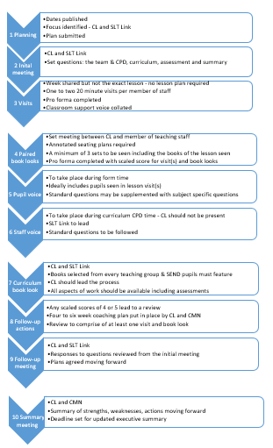
- Staff performance

We do this through:

Curriculum Reviews
- Initial review meeting SLT Link and CL
- Lesson visits
- Paired book looks
- Pupil voice
- Staff voice
- Curriculum book look
- Follow-up meeting
- Curriculum executive summaries

All curriculum review documentation can be found in R:\Curricular\Quality Assurance.

Standards
- Book looks
- Visits: lessons, reading groups and form time
- Classroom support

All standards documentation can be found in the Quality Assurance area of SharePoint.

Lesson observations
- ECTs – termly
- Teach First trainees – termly

All observation documentation can be found in the Quality Assurance area of SharePoint.

T&L Data Collections
- At least once termly visits by the T&L team to ascertain the efficacy of T&L routines and initiatives and plan for future CPD

All data collection documentation can be found in the Quality Assurance area of SharePoint.

Data and Assessment
- GCSE results
- Data assessment windows – paired data entry
- RAP documentation
- Masters of Recall assessments
- GL assessments
- Reading Age data

Student Voice
- Weekly Principal’s Breakfast
- Curriculum reviews (2-3 per year)
- T&L data collections
- Whole school student surveys
- Student interviews
- Informal opportunities

Staff Voice
- Whole school staff surveys
- Curriculum reviews
- Book looks
- CPD surveys
- Informal opportunities

External Review
- SIP visits
- MAT and subject experts
- External consultants
- Ofsted

